PTC UK Trust Cert PTC
Bursary Application form
To apply for a contribution to the costs of taking the Cert PTC you will need to fill in the form below and submit it NO LATER THAN 30th June for the academic year beginning in the following September.
Before applying
Please note the following: You will need to meet the minimum requirements for taking the Cert PTC. Please see https://www.pianoteacherscourse.org/cert-ptc-uk.
And although we always want to help, it may not be possible because funds are limited. The sum awarded would be a contribution towards the course fees, and less than half of the full fees. (And, if awarded a sum, you should declare it in your tax returns)
To apply, you need to fill in this form, accompanying it with an (optional) short video as outlined, and also provide

- Named, addressed and signed letters of support from TWO people who are familiar with your piano playing and/or teaching (e.g. your own piano teacher, or an adult piano pupil, or the parent of one of your pupils, or a professional musician who has heard you perform).
- Named, addressed and signed letter from ONE person who knows you and can confirm your financial circumstances
- If you would also like to apply for the prestigious Masayuki Tayama Bursary (see below) you will need to include a video of yourself, showing your face and hands clearly on the keys, playing the first movement (only) of any classical sonata, such as Mozart’s Sonata No. 12 in F K.332, Haydn Sonata in D Hob. XVI: 37 or Beethoven’s Sonata in F minor Op.2 No.1.

Advice and support
If you have any questions, or would like advice regarding your application form or video, please text Lucinda Mackworth-Young on 07850 912006 to arrange a mutually convenient time to talk.

Name
Address
Email
Phone number(s)
Current Employer(s)
How much are you applying for? This should be the minimum amount that you need in order to enrol on the course this coming academic year. See the website for details of current course fees www.pianoteacherscourse.org
Details of other sources from which you propose to seek funding (if any)
EITHER BY WRITING IN THE SPACES BELOW, OR BY A SHORT VIDEO (under 5 mins), OR BOTH, PLEASE RESPOND TO THE FOLLOWING 4 REQUESTS:
1.Provide a brief overview of why you are applying for this bursary. Please include information on your personal piano teaching interests and aspirations as well as your financial circumstances.
2.Describe the level of piano playing that you have reached including repertoire played and details of performances that you have given (if any). You may include the playing of a short piano piece in your video, should you wish.
3.Describe the number, ages and approximate level of your current piano pupils (if any)
4.Explain how you heard of the PTC and (briefly) why you would like to take the Cert PTC.
Sign below after reading the following statement:
I confirm that I am eligible to take the Cert PTC having met the minimum requirements as stated on the PTC website, and that the above information is true.
Signed
Printed name
Date

Please submit this form, together with the three letters of support requested above and your optional video (no longer than five minutes) to ptcuktrust@gmail.com. You may need to use www.wetransfer.com depending on the size of your file.

With many thanks for your interest and application.

The Masayuki Tayama Bursary

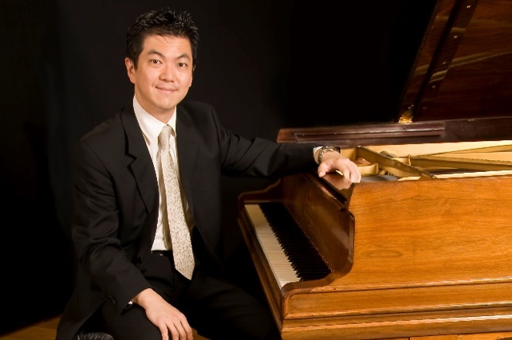
Masayuki (Masa) Tayama was Director of The PTC UK from 2019 until he sadly passed away in 2023. Helping to navigate the organisation through COVID-19 and lockdown, he used his diverse knowledge and skills to set up the online, and later hybrid, delivery of the PTC’s courses, enabling professional development to be delivered to piano teachers worldwide.
Not only was Masa a superb Director but he was also an extremely accomplished and renowned pianist and teacher. With this in mind, and thanks to the very generous donation in his memory from his father, an annual Masayuki Tayama Bursary, of up to £1,500 will be awarded to a piano player who has reached a high standard of playing (Grade 8 with Merit/Distinction, Diploma or above), a strong desire to develop their piano teaching skills but needs financial assistance.
How to apply: Please complete the application process described above and also submit a video of yourself, showing your face and hands clearly on the keys, playing the first movement (only) of any classical sonata, such as Mozart’s Sonata No. 12 in F K.332, Haydn Sonata in D Hob. XVI: 37 or Beethoven’s Sonata in F minor Op.2 No.1.
Your application will be considered first for the Masayuki Tayama Bursary, and then for a general bursary.

